**Re-letting restriction**

Where a landlord or agent ends a lease for certain reasons, there is a period where a new tenancy agreement cannot start. This is known as a re-letting restriction. The reason for ending the tenancy determines the length of the re-letting restriction. Refer to the table before for more information.

| **Reason for the tenancy ending** | **Re-letting restriction** |
| --- | --- |
| Premises no longer to be used as a rented residential premises for 12 months | 12 months |
| Proposed sale of premises | 6 months |
| Landlord or family member to reside at the premises | 6 months |
| Demolition of premises | 6 months |
| Significant renovations or repairs | 4 weeks |

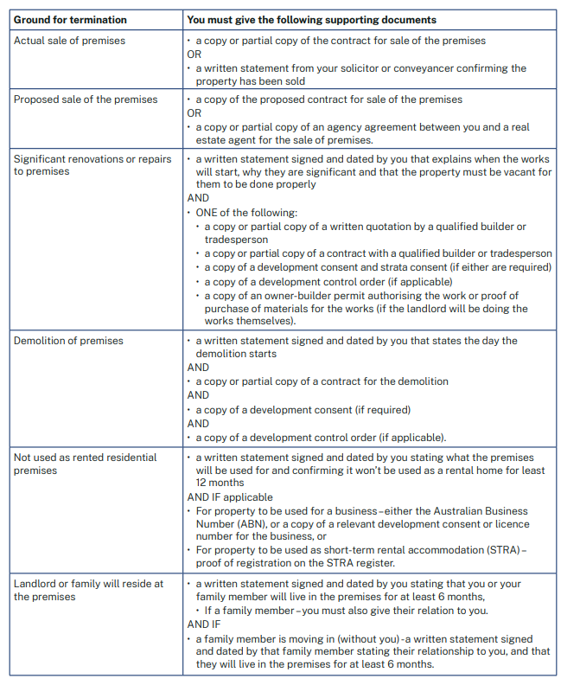

**NOTICE FOR OWNERS**

| **Ground for ending the tenancy** | **Fixed term agreement 6 months or less** | **Fixed term agreement more than 6 months** | **Periodic agreement** |
| --- | --- | --- | --- |
| **Proposed sale of property** | 60 days | 90 days | 90 days |
| **Significant renovations or repairs** | 60 days | 90 days | 90 days |
| **Change of use for the property** | 60 days | 90 days | 90 days |
| **Landlord or their family will move in** | 60 days | 90 days | 90 days |
| **Student accommodation** | 60 days | 90 days | 90 days |
| **Affordable housing scheme** | 60 days | 90 days | 90 days |
| **Transitional housing program** | 60 days | 90 days | 90 days |
| **Key worker accommodation scheme** | 60 days | 90 days | 90 days |
| **Actual sale of property** | 30 days | 30 days | 30 days |
| **Breach of agreement** | 14 days* | 14 days* | 14 days |
| **Non-payment of rent, water usage charges or utility charges** | 14 days* | 14 days* | 14 days |
| **Occupant remaining in property** | 14 days* | 14 days* | 14 days |
| **Social housing – tenant is no longer eligible** | 60 days | 60 days | 60 days |
| **Social housing – alternative premises refused** | 30 days | 30 days | 30 days |
| **Social housing – acceptable behaviour agreement breached or refused** | 14 days* | 14 days* | 14 days |
| **End of employee or caretaker agreement** | Whichever is longer: 30 days, or the notice period specified in the employee or caretaker agreement | Whichever is longer: 30 days, or the notice period specified in the employee or caretaker agreement | Whichever is longer: 30 days, or the notice period specified in the employee or caretaker agreement |
| **Death of a sole tenant** | Immediate* | Immediate* | Immediate |
| **Property is unusable** | Immediate* | Immediate* | Immediate |

**NOTICE FOR TENANTS**

| **Ground for ending the tenancy** | **Fixed term** | **Periodic** |
| --- | --- | --- |
| **End of periodic agreement**  **(This ground can be used to end a periodic tenancy for any reason)** | **N/A** | **21 days** |
| **Co-tenant ending their own tenancy** | **21 days** | **21 days** |
| **Death of a co-tenant** | **21 days\*** | **21 days** |
| **Breach of agreement** | **14 days\*** | **14 days** |
| **Non-disclosure of required information**  **Learn more:**[**What tenants need to be told about a rental property**](https://www.nsw.gov.au/housing-and-construction/rules/what-tenants-need-to-be-told-about-a-rental-property) | **14 days\*** | **14 days** |
| **End of a fixed term agreement** | **14 days** | **N/A** |
| **Early exit notice** | **14 days\*** | **N/A** |
| **Early termination without penalty** | **14 days\*** | **N/A** |
| **Rent increase** | **21 days\***  **(This ground only applies to fixed term agreements of 2 years or more)** | **N/A** |
| **Domestic violence termination** | **Immediate\*** | **Immediate** |
| **Property is unusable** | **Immediate\*** | **Immediate** |
| **Death of a sole tenant**  **(This notice would be given by the tenant’s legal representative)** | **Immediate\*** | **Immediate** |